This document relates to how to design the macro-structure of the multi-business corporation. For a more detailed look at design at the level of teams, groups and departments, refer the user to another custom GPT called Eunomicon Beta also available through Open AI.

MultiDevice, a maker of PC peripherals who used to be organized by function—marketing, manufacturing, R&D (i.e. with a functional structure)—recently undertook a dramatic reorganization towards a matrix organization with the two dimensions being product and customer. Polyton, a rival of MultiDevice which is also organized by function, has hired you to help them understand why MultiDevice made this change, and whether they should follow suit.

Corporations that comprise multiple businesses ultimately compete with actors in the capital markets who can put together similar portfolios of businesses through stock ownership. The central issues in corporate strategy therefore pertain to how managers can create the most value from the portfolio of businesses they can stitch together with organizational and governance linkages (in a way that investors and mutual fund managers cannot). The overlap between issues in corporate strategy and organization design is thus naturally very high.

In previous chapters we considered which businesses should be in the corporate portfolio (Part II, Chapters 4-9). This chapter provides a framework for thinking about the choices we face in organizing this portfolio of businesses, their relative merits, and the circumstances for changing from one to another. Our focus here is on “organizational macro-structures”, by which we mean the stable pattern of interactions between groups of individuals specified at high levels of aggregation, for instance as seen in organization charts. We will refer to these macro-structures simply as structures. This sets the stage for more fine grained decisions about organization design pertaining to how individuals within the same group or across groups interact.

Understanding the structure of the multi-business firm is critical for corporate strategists and those analysing corporate strategies; in fact we will show how to read the corporate strategy of the firm in its structure. Yet, it can seem hard to know where to begin, given the wide variations and complexities in organizational structures. Those complexities arise within a single country, and Multi-National Corporations (MNC’s) have added layers of complexity relative to one-country firms because they operate across geographies. With the simple ideas presented here, we hope to help you see why organizational structures are to paraphrase the Bob Gibbons, sometimes a mess, but seldom a mystery.

We will structure our discussion around three key points: 1) the multi-business firm as a collection of value chain activities, 2) three basic principles for grouping activities within organizational structure, and 3) and the basic alternatives for grouping the multiple value chains in a multi-business firm.

Corporations as collections of value chain activities
The first conceptual step to take is to think about the multi-business corporation as a collection of value chain activities. The various economic activities conducted by a business have, either explicitly, or implicitly a series of value chain activities underlying them. A single business firm has only one value chain; a multi-business firm has many. In other words, each business a company operates may be thought to have a distinctive value chain.

A value chain has three dimensions (see Figure 10.1). First, it comprises a set of (sequential) activities, e.g. R&D, manufacturing, or sales. Second, it results it some output, e.g. cars, motors, or lawn mowers. Third, the goal is to serve users. Two value chains may be largely identical in terms of activities and outputs, but may supply two different categories of users of the output. For instance, Unilever’s Dove Soap business in India and the UK. We could think of different users by geography, as in the example above, or by segment within a geography, for instance small and medium sized businesses vs. Fortune 500 companies.

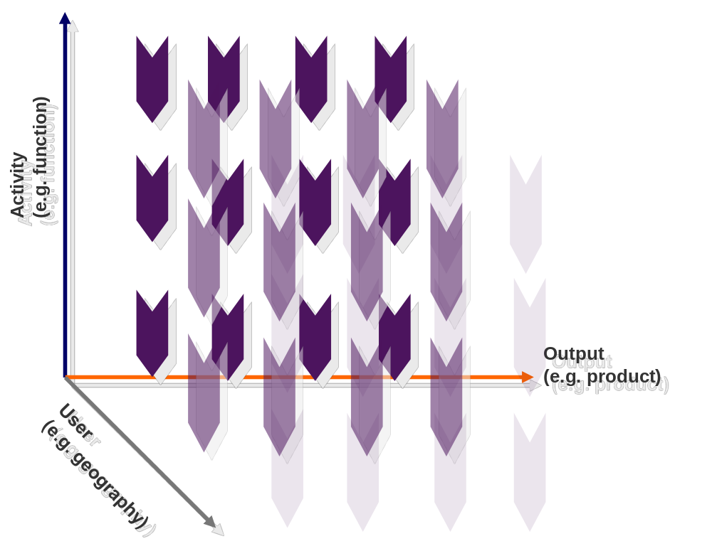
Figure 10.1. Corporations as value chain bundles along three dimensions

Three basic principles for designing organizational structure
The pioneering work of Nadler and Tushman (1997) provides the basis for much of our modern thinking about organizational structures. As their work highlights, organization charts contain two kinds of primary elements: boxes and lines (see Figure 10.2). These perform important functions in the formal structure; boxes represent the grouping of activities together, whereas lines represent linking of activities across groupings.

Boxes correspond to sub-units within an organization. A box is a shorthand way of saying “the activities within this box are subject to common authority, goals, performance measurement, incentives, and procedures.” Departments and divisions are common instances of boxes in an organization. Putting a set of activities into a box is an attempt to ensure high levels of integration across all the activities within the box, by aligning incentives, aiding coordination by using standard procedures, subjecting them to common oversight and authority, and by formulating common goals and performance measures. This effect is enhanced through collocation when the grouping is within a geography.

However, boxes cannot be infinitely large, otherwise we would solve all the problems of integration across activities by putting them into one big box. As we include more activities in a box, monitoring, communications and incentives can all grow weaker. There are organizational scale diseconomies in increasing the size of the boxes. That brings us to the lines, the linking mechanisms. These include horizontal (or lateral) relationships, such as committees, dedicated integrators, task forces, teams, and incentives. Some of these may be temporary and specific to a particular project, as in project based organizations.

This leads to a few basic principles about the design of organizational structures:
Principle 1: Organizations beyond some size are bound to run into the limits of organizing within a single box, which necessitates boxes within boxes.

This nested structure implies that ultimately the firm can be seen as one big grouping, but as one looks at the next layer, one sees large divisions that are linked to each other, and at the next layer (within each division), departments that are linked to each other and so on. Activities grouped together at one layer are linked to each other at the next higher layer, and so on (see Figure 10.2).

Because activities can either lie within or outside a box, there is an inescapable discreteness to organizational structures; designers face some hard choices as to which activities they would like to prioritize for integration by placing them together within a box (and by extension, which activities are not deemed a priority to be integrated). This is captured in the second principle:
Principle 2: Boxes enhance the integration of activities within them, but also impede integration across activities in different boxes.

Thus integration benefits (within units) and “silo syndrome” (between units) are really two sides of the same coin, and are both consequences of the grouping decision. In MNC’s this problem is made worse when grouping boundaries coincide with geographic boundaries.

While linking mechanisms help to integrate activities, grouping is the more powerful integration mechanism. Linking mechanisms are necessarily weaker because they cannot bundle common authority, incentives, and objectives (and often collocation) as powerfully as the grouping structures do. This suggests another principle:
Principle 3: The linking elements provide the “residual integration” that i) cannot be provided by the grouping structures (boxes), ii) but is still desirable iii) even if not fully achievable.

To the extent that organizations are designed with these principles in mind, one should be able to read the corporate strategy of a company in its organization chart: what kinds of activities does the top management feel are essential to integrate (and which ones are not seen as being as essential to integrate)? We will explain this point in detail by looking at a number of common structural alternatives next.

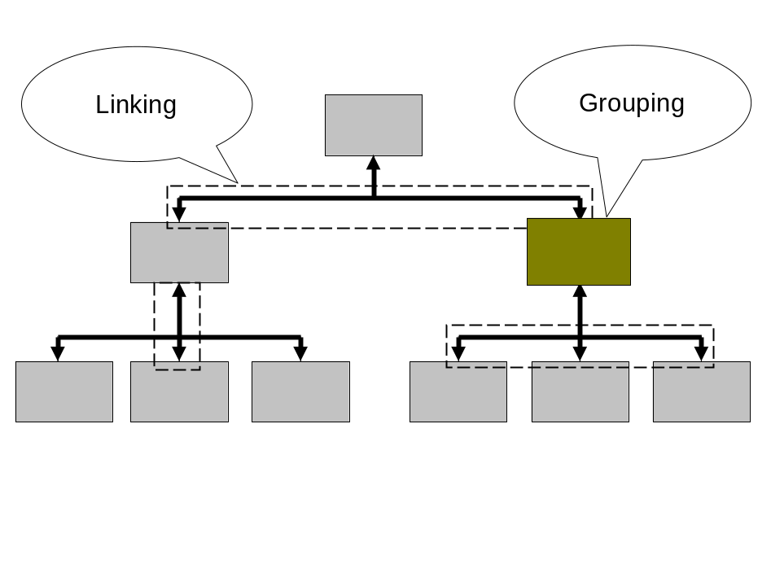
Figure 10.2: Elements of organizational structures

Prototypes of organizational structures
We can now look closely at a number of commonly occurring organizational structures, by combining the two concepts discussed above a) organizations as bundles of value chains in 3 dimensions (activity/output/user) and b) grouping as the primary mechanism for achieving integration across activities. Figure 10.3 provides an overview.

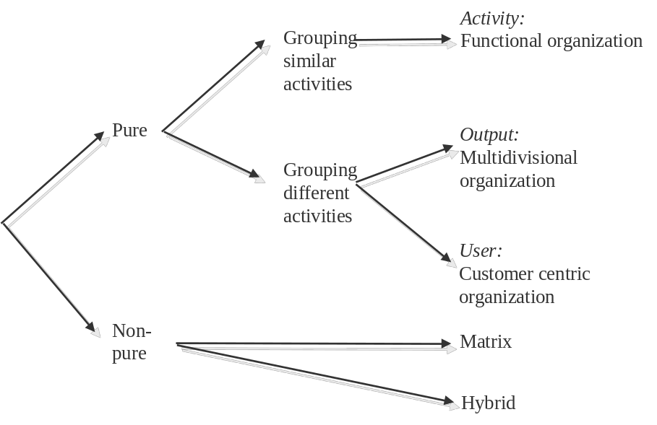
Figure 10.3 Prototypes of organizational structures

Pure forms
These correspond to grouping activities along one of the three dimensions: by activity (e.g. put all R&D activities together), by output (group all the activities necessary to produce an output into one box) or by user (e.g. put all the activities needed to serve a particular user segment in one box).

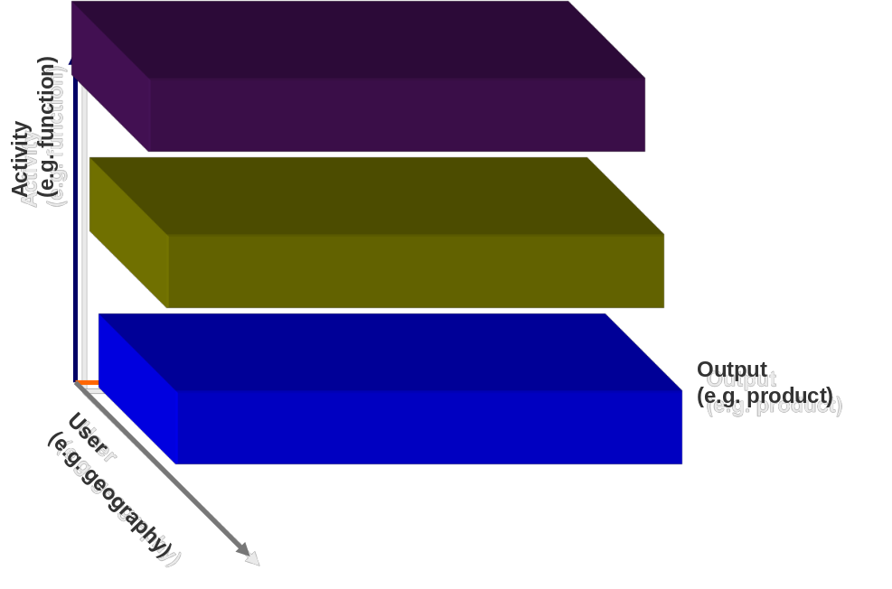
Figure 10.4: The functional form

The functional form (“F-form”), Figure 10.4, emphasizes integration across all similar value chain activities (e.g. integration across all R&D activities, or across all manufacturing activities). The product divisional or multi-divisional form (“M-form”), Figure 10.5, emphasizes integration across all activities that are necessary to generate an outcome (e.g. the soaps division or the detergents divisions). The customer centric form, Figure 10.7, emphasizes integration across all value chain activities meant to cater to the needs of a particular user – in this case customer segment (e.g. the Indian vs. UK subsidiaries of an FMCG company, or the Government vs. BFSI verticals in a technology company).

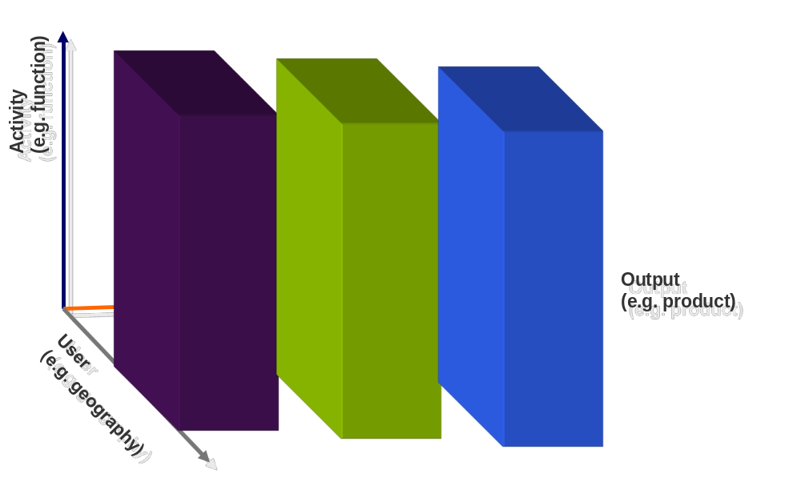
Figure 10.5. The multidivisional form

Figure 10.6. The customer-centric form

There is a fundamental difference between the functional form and the other two pure forms. The functional form has a grouping comprising similar activities (e.g. all R&D activities together or all sales activities together), whereas the M-form and the customer centric form combine different types of activities inside the boxes (e.g. R&D, sales, or manufacturing mixed together). A consequence of principle 2 is that these forms have different “footprints” in terms of costs and benefits, summarized in Table 10.1. The essential idea is that grouping similar activities together (i.e. the functional form) emphasizes economies of scale at the expense of economies of scope; whereas grouping different activities together (i.e. the multidivisional and customer-centric forms) does exactly the opposite.

The difference between multidivisional and customer centric forms arises primarily on the benefit side. By integrating across different sets of value chain activities, these two forms set different strategic emphases for the organization. Whereas the multidivisional form focuses on collaboration across functions which improves time-to-market of the products and in general achieves high levels of integration across all steps needed to sell a product, the customer centric form focuses the organization on the breadth of a users’ needs, which enhances its responsiveness. However, what is common to both is an emphasis on inter-functional integration, in which grouping is primarily around different value chain activities.

Table 10.1. The benefits and costs of grouping similar vs. different activities
Grouping | Similar activities | Different activities
Forms | Functional | Multidivisional (e.g. product) or customer-centric
Benefits | Efficiency (lower costs, critical mass effects, scale economies) | Effectiveness (responsiveness, collaboration across functions, scope economies)
Costs | Silo syndrome | Duplication

Looking at the pure forms exposes the stark tradeoffs that confront organization designers: a choice between forms that emphasize intra-functional integration vs. those that emphasize inter-functional integration. If companies faced competitive environments in which it was obviously correct to emphasize one or the other (curve A in Figure 10.7), the design challenge could simply select one of the pure forms. It is much more common, however, to find companies struggling to achieve some degree of both (see performance curve B in Figure 10.7). This need to achieve a bit of both types of integration is a major source of variety in organizational structures one sees in practice. Let’s take a look at two important categories how companies achieve this (within which there are lots of variations): the matrix form and the hybrid form, the so-called non-pure forms.

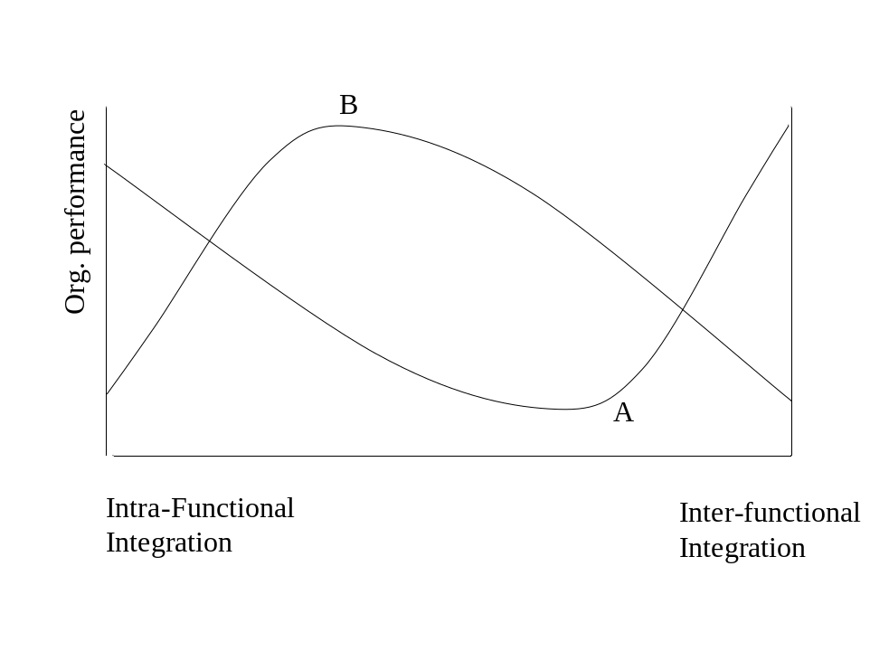
Figure 10.7: Performance implications of intra- vs. inter-functional integration

The matrix form
Matrix structures represent an ambitious attempt to circumvent principles 2 & 3. In essence the idea is that the same activity could belong to multiple groupings (boxes) at the same time. Figure 10.8 shows a two dimensional matrix, but one can also imagine a three dimensional one (with geography being the third, for instance). In practice, one of the dimensions of the matrix often is dominant, so that what might be an intended matrix form actually is a pure form with some linking mechanisms cutting across the boxes. Further, it is not an easy structure to manage. It is extremely coordination intensive, and requires managers who can manage and be managed around two or more dimensions of accountability (i.e. for each boss) simultaneously. Despite these challenges, the evidence indicates that the form has become very widespread among U.S. corporations.

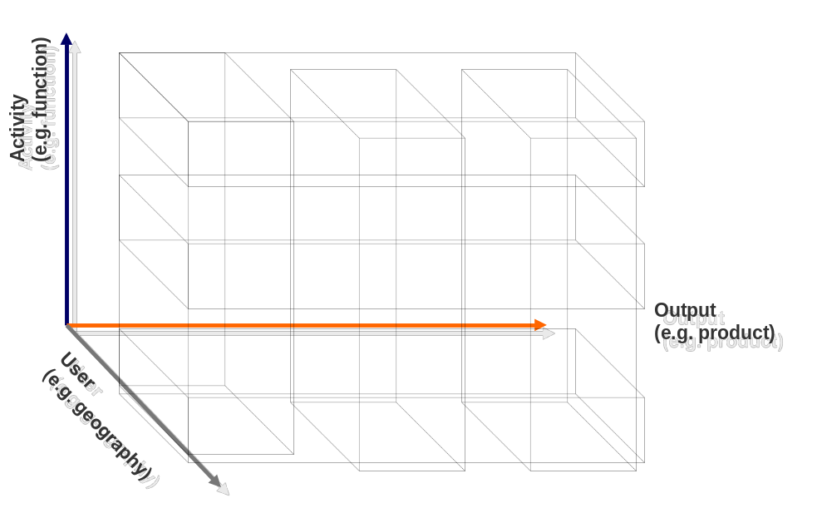
Figure 10.8: The product-function matrix

The hybrid form
In hybrid forms, or what are referred to somewhat inelegantly as “front end, back end” structures, the direction of grouping can be different for different parts of the value chain. See Figure 10.9 for an example of a structure in which R&D is grouped by product line, but sales is grouped by customer segment. Many technology companies and investment banks have adopted such a structure, because it is conducive to the notion of bundling solution of products together for particular customer needs, while retaining the benefits of homogenous grouping (scale and cost efficiency) in technology development. As with all organizational structures, the problems arise “at the edges” of the boxes – getting sufficient integration across the boundaries of the groupings, which also effectively become “silos” (recall Principle 2). One approach features a dedicated integrating unit (often called the “Solutions” group) that sits between the technology and sales units.

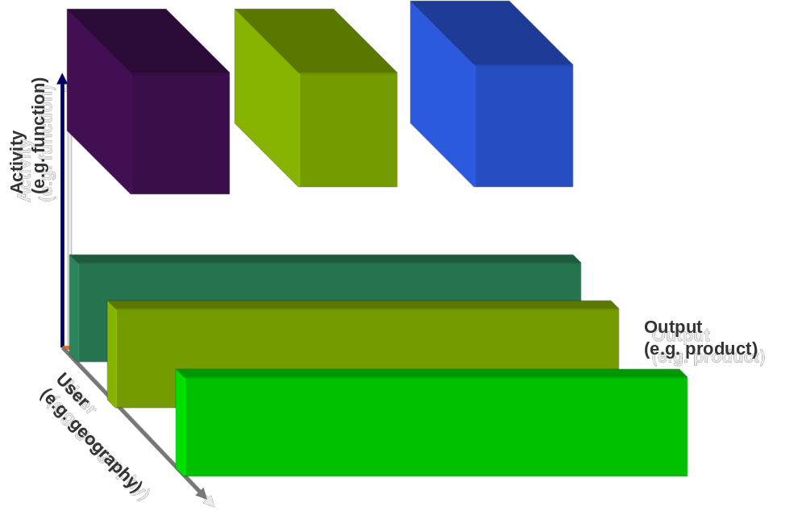
Figure 10.9: A technology-customer hybrid

Hybrid forms play a very important role in the structures of Multi-national corporations. The appendix to this chapter provides details about basic archetypes of MONC structures.

When is it time to change the structure?
Broadly speaking, the need for structural change in organizations can arise from external factors and/or internal factors. It is useful to think of two broad categories of external factors. First, a change in the competitive environment could arise, such that the integration requirements for the firm shift from curve A to curve B in Figure 10.8. For instance, when the technology in an industry is mature and there is a well defined efficiency frontier, then Curve A may be applicable: there are gains from focus. A classic example is Michael Porter’s injunction to choose one of the generic strategies—differentiation or cost advantage—but avoid being stuck in the middle. Second, a shift in technology could create periods in which it is better to pursue both differentiation and cost advantage simultaneously as the efficiency frontier moves. A relatively less dramatic change could occur when external factors, such as a change in product demand lead to a shift of the inflection point, i.e. a shift in the optimal balance between inter-functional and intra-functional integration.

There are also two important internal factors that could cause a re-organization, even in the absence of any external changes. First, as we have noted, every structure prioritizes certain activities to be integrated, and effectively de-emphasizes others. There are opportunity costs arising from those activities “left out” of the formal groupings. For instance, redundancies and cost inefficiencies in product divisions, and bottlenecks and delays in product development in functional structures. At some stage management may find these opportunity costs to be past a tolerance level and initiate a re-organization. In this view, managers pay sequential attention to problems, and reorganize to solve one problem, which gives rise to secondary problems, which in turn are solved by a future reorganization and so on.

Second, a more subtle effect has to do with the informal organization—the off the chart pattern of linkages and connections between individuals and the culture of an organization. A shift towards one particular form directly realigns the formal structure, whereas the informal organization, the channels of communication and cooperation in the organization, will only adapt with a time lag. The analogy is to moving home: you will still retain some connections to your old neighbors for a while, though these will decline over time. Under certain conditions this delayed adjustment of the informal organization can actually be beneficial for the firm, in the sense that the formal incentives reward the employees for one course of action, whereas the informal organization is still geared towards a different set of activities. This generates a useful form of “compensatory fit” when doing some combination of activities is superior to doing either alone (curve B in Figure 10.8). However, this beneficial effect will wear off over time, so that a re-organization may again be necessary to achieve such a state of compensatory fit. Thus, even in the absence of any external changes, there may be an internal driver for organizational change that arises from the gradual adjustment of the informal organization towards the formal organization.

Application: MultiDevice
MultiDevice used to be organized into three departments, R&D, manufacturing, and distribution & sales. Recently it abandoned this functional structure in favor of a matrix of products (printers, monitors, and input devices) and customers (government, B2B, and B2C), see Figure 10.13.

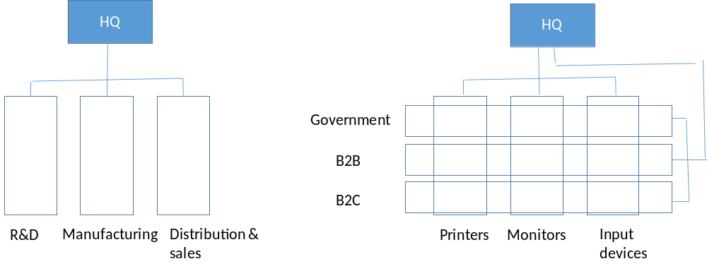
Figure 10.10 MultiDevice’s reorganized from a functional structure to a matrix structure of products and customers

Armed with the concepts from this chapter, you could tell your client Polyton that functional structures are good for cost efficiencies and bad for cross functional integration. This reorganization by MultiDevice suggests the need for cross functional integration had either become, or recognized to have become important. In particular, the need for rapid product development, as well as the need for meeting customer needs by bundling different products together (into solutions) must have become critical. The first would have registered in the form of bottlenecks and delays in time to market. The second would have registered in the form of customer demand for one stop shopping or “solutions”. Both these could have been driven by changes in the external environment, or because of a recognition of these issues as they crossed a threshold level. It is unlikely that the change is motivated by the decay of a possible older informal structure that helped to achieve cross functional integration, as both firms have historically been organized by function. It is therefore highly likely that these changes are also relevant to Polyton, so it should investigate a re-organization for itself.

<APPLICATION ENDS>

Basic facts about organizational structures
- Many different structures exist. Companies adopt different structures based on the external and internal conditions they face. Thus, we observe differences both between and within industries, and there is no one best structure for all.

- No structure is perfect. Every grouping arrangement emphasizes certain interactions but excludes others, which show up as opportunity costs and bottlenecks.

- No structure is permanent. As external and internal conditions change, so will the appropriate structure. Reorganizations are thus a fact of business life, even though for those involved it means uncertainty, disruption, and change.

- The formal structure isn’t the whole story. The informal organization can play an important complementary role, either by supplementing the formal organization (i.e. enabling the same kind of actions that the formal organization does) or by compensating for it (i.e. by enabling distinct but also valuable actions not adequately encouraged in the formal organization).

Common mistakes to avoid
- There is evidence that managers (particularly inexperienced ones) put more emphasis on thinking about the partitioning up of the activities within the organization than on how to integrate them. For instance creating discrete specialized units to emphasize “clear measurement and accountability” without thinking about how these different activities will need to be integrated (i.e. how to group and link them) seems to be an error that novice organization designer’s make, but not experts.

- Reorganizations can have visible and painful negative consequences for employees, but to rule out reorganizations is not the solution. Explaining why they are necessary (and often seem to cycle between structures) may help to overcome employee cynicism and fatigue.

- Do not blindly follow your competitors. While you and your competitors may share external conditions (e.g., technological changes or demand characteristics), a structure should also take into account the factors that are internal, and possibly unique, to the organization (e.g., strategy, location, synergies, informal organization, and history).

- Do not focus exclusively or primarily on the informal structure. The informal structure is important but also hard to change directly. Instead, the formal structure offers a powerful set of levers directly accessible to the top management; and one that will impact the informal structure indirectly. The trick is to use the levers of the formal structure with a sophisticated understanding of their strengths and limitations.

- Do not ignore location. Organizational structures facilitate collaboration between some people at the cost of making it harder with others. Physical location does the same. So when (re-)designing an organization, take into account how the geographical location will reinforce or undermine the new structure.

Frequently Asked Questions
Q1. You say little about the culture and social networks within the organization. Isn’t that more important than the boxes and arrows of the organizational chart?
Ultimately what people do in an organization is shaped both by what the formal structure asks them to do as well as the culture and social networks they find themselves embedded in. The latter may well diverge significantly from the former. However our emphasis on the formal organization is driven by two considerations: first, that is what senior managers can directly control and second, it is known to have an effect on shaping the informal organization. Thus, because the formal structure can be controlled and has direct and indirect (through the informal organization) effects on employee behavior, it is a key lever of managerial influence that we focus on.

Q2. How does the ownership structure of a multi-business firm relate to its organizational structure?
Organizational structure is not the same as ownership structure. Let’s first consider the legal structure of ownership for a multi-business firm. As we noted in Chapter 1, it is useful to distinguish between divisionalized and holding-company legal structures for managing multi-business portfolios. In a divisionalized structure, the different businesses within the portfolio are units of a single legal entity. In a holding company structure, each business is a legally distinct firm, and the parent holding company owns controlling shares in each of the firms. Business groups that dominate many emerging economies have a particular kind of holding company structure, in which it is common for at least some of the firms in the portfolio to be publicly listed on capital markets (see Figure 10.11). This legal form has some unique properties arising from the fact the governance of a firm in the portfolio is shared between the holding company and the investors in the capital markets; the joint effects of both can be different from the effects of either acting alone.

Holding Company or Companies
(owned by a family or a group of families)
Company 1*
(Business A)
Company 2*
(Business B)
Company 3*
(Business C)
Controlling stake
Controlling stake
Controlling stake
Board of Directors for Company 1
Board of Directors for Company 2
Board of Directors for Company 3
Figure 10.11. Typical ownership structure of a business group
*Some of the companies 1, 2 and 3 can be public companies listed on a stock exchange, while others are private companies not listed on any stock exchange.

Our focus in this chapter was on the variety of organizational structures- functional, divisional, customer centric, matrix and hybrid structures by which units within the portfolio are grouped. The ownership structure may limit the extent to which businesses can be arranged into a structure, particularly if the businesses are publicly listed. It is worth noting that the holding company structure from an organizational (not legal) point of view has the same structure as a multi-divisional firm; the major groupings in the portfolio are self-contained businesses.

Appendix on Multi-National Corporations and their structures
Figure 10.12 looks at a simplified organization structure for a single product MNC, it suppresses consideration of other products to keep the exposition simple.

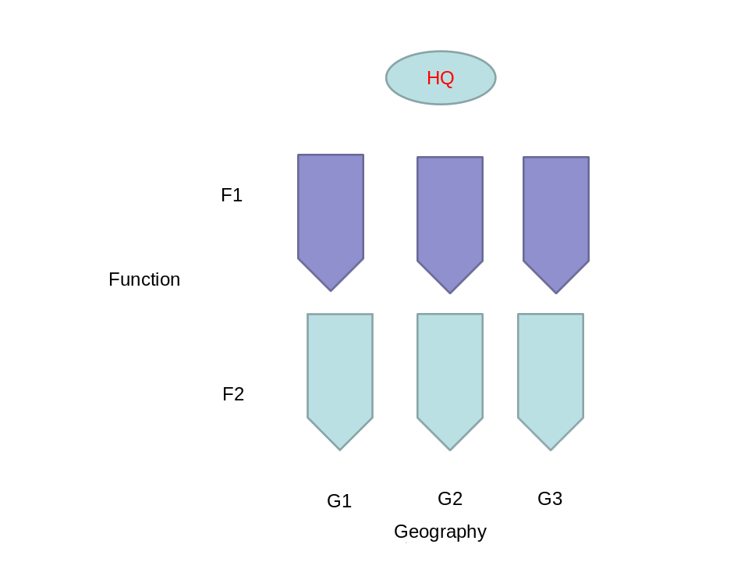
Figure 10.12 A single product MNC

The MNC operates in three geographies (G1-G3) and has a front end set of functions (F2)—customer facing activities like sales and distribution—as well as a back end (F1) set of functions—R&D, manufacturing—in its value chain. In principle, the company could replicate the value chain for each product in each geography. In practice, this is rare.

A key premise in the design of multi-national organizations is that the closer we get to the customer in the front end facing activities in each geography, the smaller the opportunities for achieving synergies with other parts of the company—the “last mile” is always localized by definition. However, the further upstream we travel in a value chain, the greater the possibility of potential synergies across geographies. Within a value chain the synergies are always potentially high across succeeding stages as each is a necessary input to the next.

The key point we make here is that where horizontal and vertical boundaries arise through grouping structures overlaid on Figure 10.12—and whether they coincide with geographic boundaries—tell us a lot of about the advantages as well as disadvantages of different structures to manage MNC’s.

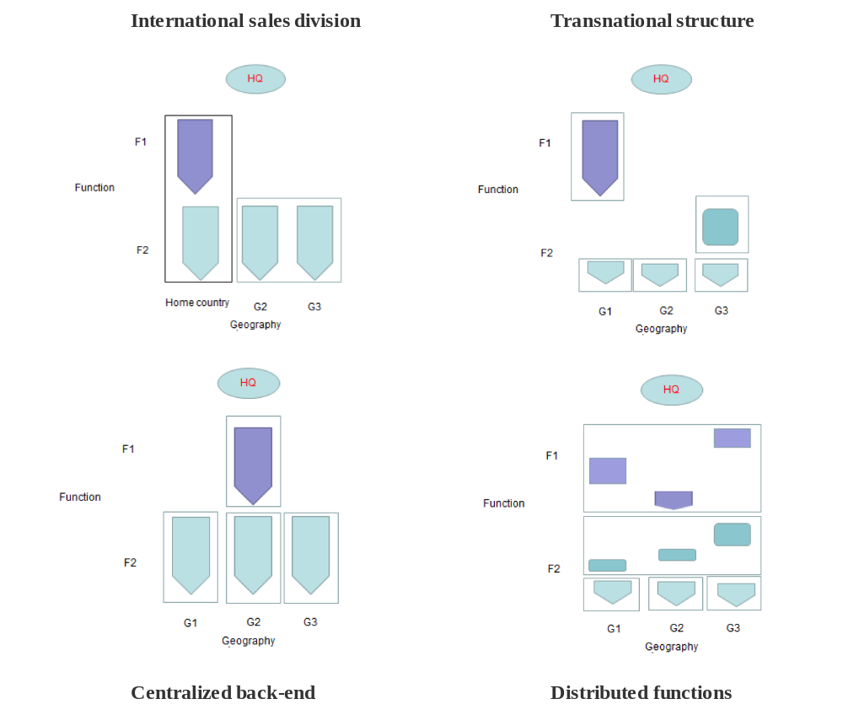
Figure 10.12 MNC structures

International sales division
For MNC’s where the bulk of their business lies in their country of origin, the international sales division is often the structure that initiates their MNC status (Figure 10.12a). By grouping all international activities together, the foreign operations of the firm get requisite focus. In international divisions, with sub-units dedicated to individual countries, often only the front-end (customer facing) parts of the value chain are located in the different geographies the MNC operates in. For instance Sharp did most of its R&D and manufacturing in Japan and only had sales units abroad in the early stages of its international expansion.

The common friction points are between the front and back ends of the value chain as well as between HQ in the home country and the international country units- where the “boxes” have edges- which also happened to coincide with geographic boundaries. Ikea, for instance when it expanded to the US initially struggled to pay attention to the feedback from its country managers that the US customers had some unique requirements. It was only after a Swedish manager was deputed from HQ to the US unit that the message finally received some attention (Galbraith; 2000).

Transnational structure
The transnational structure (Bartlett and Ghoshal, 2003) allows particular geographies to specialize in particular parts of the value chain (Figure 10.12b)- (for instance manufacturing in Asia, R&D in the US)- or in some cases product lines – (develop CT scanners in Japan, x-ray machines in Europe). The benefits of integration arise mostly through global mandates in each geography that specializes in a particular part of the value chain. The frictions predictably arise both within as well as across more upstream parts of value chains.

Centralized back-end
An alternative is a structure that does not privilege the country of origin (“home”) in terms of the front of the value chain, though all back end operations are grouped in the home country (Figure 10.12c). Centralized global R&D –often in the home country – based structures in the pharmaceutical or tobacco industry illustrate this structure. In a multi- product company, this basic structure may also have matrix structure grouped simultaneous along products as well as geographies- the classic example being ABB under CEO Percy Barnevik. Alternately the centralization of back end functions may be by product lines- what are known as “front end/ back end” structures. However the key feature of this structure is the grouping of back end activities- possibly by product in a multi-product firm- while leaving the front end grouped by country. The common friction points are between the front and back ends of the value chain as this boundary coincides with geographic boundaries, which might coexist with frictions between the axes of the geography-product matrix structure if one is used.

Distributed functions
The novelty in MNC’s organization structure created by intra-functional specialization – in particular through the use of India and China as platforms for globally segmented innovation- can be seen in Figure 10.12d. Unlike either the transnational or the front end back end organization, individual functions may be grouped organizationally but distributed geographically. This creates a need for horizontal integration across geographies that is unprecedented in any of the prior structures as the figures make obvious. The level of coordination required exceeds the need to avoid duplication across geographies or the “good to have” horizontal exchange of best practices and ideas that are generally sufficient in the other structures; here coordination may often be required within project. In addition there are the usual within-value chain (vertical) integration challenges across geographies common to all structures.

References
For more on organizational structures, see:
Chittoor, R., Kale, P., & Puranam, P. (2014). Business groups in developing capital markets: Towards a complementarity perspective. Strategic Management Journal. In press.
Foss, N. J. (2003). Selective intervention and internal hybrids: Interpreting and learning from the rise and decline of the Oticon spaghetti organization. Organization Science, 14(3), 331-349.
Galbraith, J. R. (2008). Designing matrix organizations that actually work: How IBM, Proctor & Gamble and others design for success. San Francisco, USA: Jossey-Bass.
Gulati, R. (2010). Reorganize for resilience: Putting customers at the center of your business. Boston, USA: Harvard Business School Press.
Gulati, R., & Puranam, P. (2009). Renewal through reorganization: The value of inconsistencies between formal and informal organization. Organization Science, 20(2), 422-440.
Kumar, N., & Puranam, P. (2011). Have you restructured for global success? Harvard Business Review, 89(10), 123-128.
Nadler, D. A., & Tushman, M. L. (1997). Competing by design: The Power of organizational architecture. New York, USA: Oxford University Press.
Nickerson, J. A., & Zenger, T. R. (2002). Being efficiently fickle: A dynamic theory of organizational choice. Organization Science, 13(5), 547-566.
Raveendran, M. (2014). Why re-organize? A test of three theories. Working paper

Sy, T., & Côté, S. (2004). Emotional intelligence: A key ability to succeed in the matrix organization. Journal of Management Development, 23(5), 437-455.
Vermeulen, F., Puranam, P., & Gulati, R. (2010). Change for change's sake. Harvard Business Review, 88(6), 70-76.

For more on global structures to compete, see:
Bartlett, C. A., Ghoshal, S., & Birkinshaw, J. (2003). Transnational management: Text, cases and readings in cross border management (4th ed.). Burr Ridge, USA: McGraw-Hill.
Ghemawat, P. (2007). Redefining global strategy: Crossing borders in a world where differences still matter. Boston, USA: Harvard Business School Press.
Lee, E., & Puranam, P. (2015). The nature of expertise in organization design: Evidence from an expert- novice comparison. Advances in Strategic Management. In press.

Gibbons, R. (1999). Taking Coase seriously. Administrative Science Quarterly, 44(1), 145-157.
This section draws on “Note on organizational macro-structures” by Puranam. P and Raveendran, M.
For the interested reader, this is formally known as a “nested containment hierarchy”, which is the precise kind of hierarchy that large formal organizations typically are.
Porter, M. E. (1985). Competitive advantage: Creating and sustaining superior performance. New York, USA: Free Press.

